**ITESM CAMPUS QUERÉTARO**

**INSTITUTO TECNOLÓGICO Y DE ESTUDIOS SUPERIORES DE MONTERREY**

**DEPARTAMENT OF COMPUTER SCIENCE**

**Software Architecture and Design**

**Course Project – HLD**

SAN HUMBERTO

High Level Design

|  |  |  |  |
| --- | --- | --- | --- |
| Area: | Web Systems | Document Number: | 1 |
| Date: | 10/Sept/2016 | Document Version: | 1.0 |
| Author: | Francisco Núñez Gomez |  |  |
| Short Description: | Monitoring system for calves. | | |

Revision History

|  |  |  |  |  |
| --- | --- | --- | --- | --- |
| Version | Date | Author | Section | Description |
| 1.0 | 13/Sept/2016 | Francisco Núñez Gómez | All | Document definition |
|  |  |  |  |  |
|  |  |  |  |  |
|  |  |  |  |  |
|  |  |  |  |  |
|  |  |  |  |  |
|  |  |  |  |  |

Sign-off

Product Marketing Date

Developer Date

Director IS Systems Development Date

Servers and Networks Date

Project Manager Date

Sr. Marketing Manager Date

Telecom Date

Servers and Networks Date

Distribution List

1. Francisco Núñez

TABLE OF CONTENTS

1 Purpose of this document 7

2 Intended audience 7

3 Functional Description 8

3.1 Functional Overview 8

3.2 Logical Flow and Business Rules 8

3.3 Architectural Overview 8

3.4 Application component additions or modifications 8

3.4.1 Business Objects **Error! Bookmark not defined.**

3.4.2 Pages or Forms 9

3.4.3 Database Modifications 9

3.4.4 Interaction With Other Modules or APIs 9

3.5 Application Configuration Dependencies **Error! Bookmark not defined.**

3.5.1 Runtime Parameters **Error! Bookmark not defined.**

3.5.2 Other Requirements **Error! Bookmark not defined.**

3.6 Error Conditions 9

3.6.1 Application Exceptions 9

3.6.2 System Exceptions 9

3.7 System Dependencies/Interaction 10

3.8 Other Technical Issues 10

3.9 Hardware/Software Environment Overview 10

4 Configuration/Installation Steps 10

5 Unit Test Plan Error! Bookmark not defined.

6 Project Timeline 10

6.1 Phase 1 – <for a multi-phase project include a subsection for each phase> **Error! Bookmark not defined.**

7 Appendix A – Glossary of Terms Error! Bookmark not defined.

8 Appendix B – Related Documents Error! Bookmark not defined.

9 Appendix C – (as needed) Error! Bookmark not defined.

10 Appendix D – (as needed) Error! Bookmark not defined.

# Purpose of this document

This document presents the initial considerations on high level design for the Monitoring System of the calves in the San Humberto ranch as well as other related technical aspects

# Intended audience

This document is intended for the professor that will supervise this project.

# Functional Description

## Functional Overview

This system provides the employees and the manager of the ranch an easy way to keep track of all the data related with the calves as well as it serves as a tool to visualize and compare it through reports. It also helps to keep the record in a more organized way as it is stored in the data base instead of archiving papers.

## Logical Flow and Business Rules

Here is the main module of the system where the employee can consult any of the registered calves and update the information based on its daily check. The other diagrams would be simply the CRUDS of employees and calves.

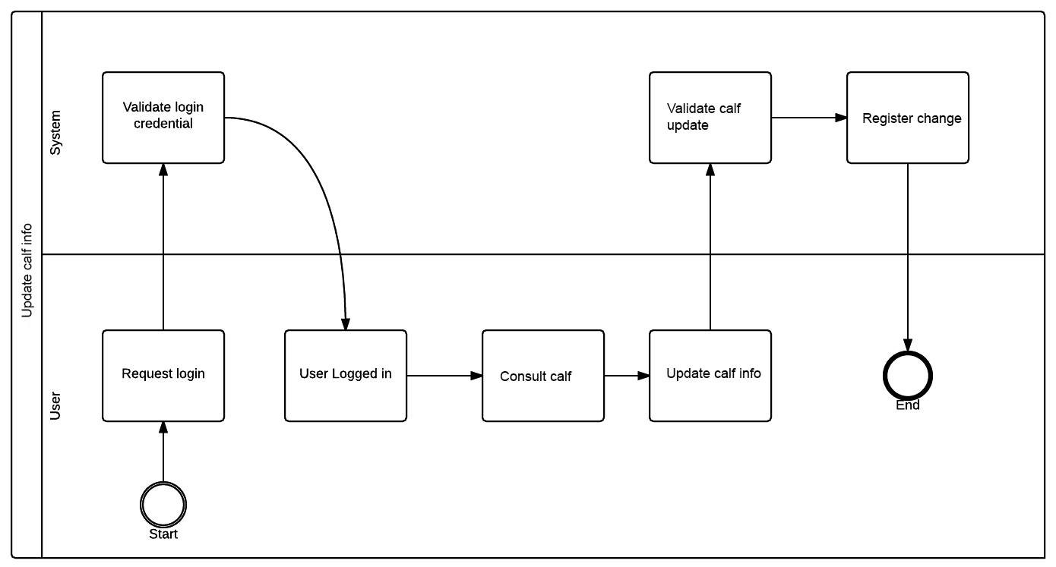

## Architectural Overview

## 

MySQL

DB Server

DB

Windows Server

Client

Plex

Browser

PHP

I’ll be using the MVC architecture as it is a simple system and need no more complexity for an optimal performance. For the backend I will be using PHP without any framework and for the frontend I will be using Typescript which is an alteration of JavaScript in order to make it typed and object oriented.

## Application component additions or modifications

Since it is a new project, no modifications will be made, every new element will be added to it.

### Pages or Forms

Dynamic:

* Home (view)
* Calf info (form)
* Reports (view)
* Login (form)
* Calf catalog (view)

### Database Modifications

N/A

### Interaction with Other Modules or APIs

N/A

## Error Conditions

### Application Exceptions

* Invalid login credentials
* Not enough permissions
* Wrong data types on forms

### System Exceptions

* Connection error
* Error while writing at database
* Loading error

## System Dependencies/Interaction

Include a list of what systems or other applications this application will interact with or affect. Be sure to include details on which of these systems this application depends on, along with what will happen in the event of a failure in the other system. Include any steps required to get this application back to a normal state once the other system is back up.

## Other Technical Issues

As the system will be user on tablets, the hardware may be at risk by the ranch environment like the dirt or even the cows and calves.

## Hardware/Software Environment Overview

Hardware: desktop and tablets on the field, no specific hardware requirements other than internet connection.

Software: Windows server running with PHP

# Configuration/Installation Steps

This specification will be fulfilled in the final version of this document.

# Project Timeline

This section gives a high-level listing of the major components of the project timeline, with estimations of duration. A reference should be included to the Project Plan, where a more detailed breakdown of the steps can be found. The table below contains suggested categories for use, but these should closely follow the major categories of the Project Plan itself.

|  |  |  |
| --- | --- | --- |
| **Category** | **Detailed Description** | Estimated Time |
| Research | Define what the project is going to be about, and what  purpose it serves. | 2 weeks |
| Documentation | Production of the required documentation for the system such as FRD, HLD, CMR. | 3 weeks |
| Code | Develop the system driven by a TDD approach. | 5 weeks |
| Unit Testing and debugging | Run the tests one last time and debug before deploying | 1 week |
| Deploy | Deploy the final system in a public URL or IP | 1 week |
|  | **TOTAL estimate** | 12 weeks |